

Universidad Católica de la Santísima Concepción

Facultad de Ciencias

Alonso de Ribera 2850,

Chile, CP 4090541

(+56) 41-2347027 Santiago, Chile, 24 March 2023

*Dear Editor,*

*I am writing to you on behalf of my co-authors in response to the comments provided by the anonymous reviewers for our manuscript entitled, "Hydroclimate Variations Over the Last 17,000 Years as Measured by Leaf Waxes in Vegetation Physiognomic and Rodent Middens from the South Central Atacama Desert, Chile." Please find enclosed our detailed responses to the reviewers' comments. We would like to express our gratitude to the reviewers for their meticulous evaluation of our manuscript. Their feedback has significantly enhanced the quality of our work. We have carefully considered and addressed all the comments and concerns raised by the reviewers, and we believe that our revisions have resulted in a substantially improved manuscript. In this document, we have provided a comprehensive explanation of the changes we have made to the manuscript in accordance with the reviewers' recommendations. We are confident that these revisions have strengthened our study and we look forward to the possibility of its publication in Quaternary Science Reviews.*

*Sincerely,*

*Matías Frugone-Álvarez*

## 1. Response to referee #1

### 1.1. General Comments referee #1:

**Overview and general recommendation**

The study of long chain n-alkyl lipids from rodent paleomiddens in the Atacama Desert can inform on long-questioned responses and thresholds to climate variations.

In this study the authors contribute to make clear what impact climate changes had on vegetation physiognomy and how it reconfigured climatic dynamics. This transfer of new results and already established climate reconstructions provides new insights on plant species distributions and their diversity on the molecular level. This study is very good written and nicely structured. I also think it fits very well into the scope of the journal. Since I haven’t read such a good study a long time and as there are only a few of such studies available especially for the Atacama Desert, I strongly recommend supporting this study with only some very minor comments just for notice.

**1.2. Specific Comments referee #1:**

**1.2.1. Specific Comments**: **Please can you be more precise in the abstract, I think at some stages it is still very general (e.g., please indicate the elevational gradient you covered and so on..)**

*Reply specific comments 1.2.1* : We agree with our reviewer, and we have changed the abstract to:

*“Leaf cuticular waxes are one of the most important environment-plant interaction structural systems that enable desert plants to withstand extreme climatic conditions. We present a long chain *n*-alkyl lipids study in fresh plant leaves and rodent paleomiddens collected along an elevational gradient in the south-central Atacama Desert of Chile, covering six different vegetation physiognomies: Steppe (4,500-4,000 m asl), Puna (4,000-3,300 m asl), Prepuna (3,300-2,400 m asl), Absolute Desert (2,400-2,000 m asl), Desert (1,000-2,000 m asl), and Coastal Desert (1,000-0 m asl). The 28 rodent paleoenvironments analysed from Quebrada Incahuasi (25.6 $^\circ$S, 3,600 m asl) span the last 17,000 years. The distribution of long-chain *n*-alkanes and *n*-alkanoic acids varies among the dominant plant associations of the Atacama Desert. These plants show a species-specific chemotaxonomy linked to the climatic conditions. Furthermore, differences in average chain length (ACL) and carbon preference index (CPI) suggest that these plant communities have adapted to these extreme environmental conditions. The sum of leaf wax *n*-alkanes was highest under wet conditions, while *n*-alkanoic acids (between *n*-$C_{24}$ and *n*-$C_{28}$) increased with hyperaridity. Similarly, analysis of *n*-alkane time series from paleomiddens showed that the greatest changes in leaf wax *n*-alkane distributions (ACL and CPI) corresponded to the greatest increases in moisture during the Central Andean Pluvial Event (CAPE; between 18 and 9 ka cal BP) and the Late Holocene. The shift in the paleomidden *n*-alkane distributions is corroborated by the relative abundance of rainfall-dependent extra-local taxa. This is the first study to report leaf wax content obtained from ancient rodent middens, and shows promising results as a robust hydroclimate proxy for the Atacama Desert region.”*

**1.2.2. Specific Comments: Please use n in italics through the abstract and whole manuscript**

*Reply specific comments 1.2.2 : We appreciate the reviewer's comment. Done*

**1.2.3. Specific Comments: Average chain length and Carbon preference index with small capital letters**

*Reply specific comments 1.2.3 : Done*

**1.2.4. Specific Comments: hyperaridity not with I**

*Reply specific comments 1.2.4 : Done*

**1.2.5. Specific Comments: Did you calculate the recovery of n-alkanes and n-alkanoic acids? Please add on this.**

*Reply specific comments 1.2.5: Done. Average recoveries are ~80%. Recovery percentages will be available in the raw data on Github and Zenodo (pending of review decisions) (github:https://github.com/mat1506/atacama.waxes.git.).*

**1.2.6. Specific Comments: What about contamination during sampling? Can you give information about special concerns**

*Reply to specific comments 1.2.6: Samples were taken using leather gardening gloves without directly touching the leaf part and placed in paper bags and then stored in glass jars in the laboratory.*

*We have added the following paragraph to the manuscript:*

*We collected fresh leaves of the dominant species in 15 sites along an elevation gradient from the coast (MAP; ~ 4 mm, MAT; ~ 14ºC) until 4,300 m asl following the methodology described in Diaz et al., 2016, 2019. Plant cover was measured in the field by visual description where species were scarce and by the point interception method where vegetation was more abundant. “Samples were collected using gardening gloves without directly touching the leaf part and placed in paper bags and then stored in glass jars in the laboratory.”*

**1.2.7. Specific Comments: Please order the citations from old to new in the text.**

*Reply specific comments 1.2.7: Done*

**1.2.8. Specific Comments: Please watch out with the units you use. Sometimes you write gdw, then g dw or even several other options. Please harmonize that.**

*Reply specific comments 1.2.8: Done*

**1.2.9. Specific Comments: What about repetitions?**

*Reply specific comments 1.2.9: Replicates were made on plants of the same species along the transect in the same vegetation belt. However, the study is correlational and only considers into account the dependent and independent variables. In the case of fecal pellets from middens, we simply ground several pellets from the same middens and compared the grasses and pellets from these paleomiddens. Future research could certainly include a repeatability experiment within the same paleomiddens.*

**1.2.10. Specific Comments: What about the setup of the gas chromatograph? Please add**

Reply specific comments 1.2.10: Done. *We have added the following paragraph to the manuscript:*

*“The n-alkanoic acids and n-alkane waxes were quantified using gas chromatography with flame ionization detection (GC-FID 7890A; Agilent Technologies) and identified via GC--mass spectrometry (GC--MS:QP-5050A-Shimadzu) based on the retention time and spectra of standards for each compound. The temperature program started at 50 °C for 1 min, increased to 130 °C at 10 °C/min, then to 325 °C at 4 °C/min, and then remained isothermal for 15 min.”*

**1.2.11. Specific Comments: How did you analyze plant coverage at the sites? Please add**

*Reply specific comments 1.2.11: Plant abundance, richness and linear cover were measured in the field by visual description where species were scarce and as point occurrences along four transects of 20 m length and 10 m spacing at each site where vegetation was more abundant. The method used to measure coverage was the same as that used in the manuscripts:*

*- Díaz, F.P., Frugone, M., Gutiérrez, R.A., Latorre, C., 2016. Nitrogen cycling in an extreme hyperarid environment inferred from d15 N analyses of plants, soils and herbivore diet. Scientific Reports 6, 22226. doi:10.1038/srep22226.*

*- Díaz, F.P., Latorre, C., Carrasco-Puga, G., Wood, J.R., Wilmshurst, J.M., Soto, D.C., Cole, T.L., Gutiérrez, R.A., 2019. Multiscale climate change impacts on plant diversity in the Atacama Desert. Global Change Biology 25, 1733–1745. doi:10.4261111/gcb.14583.*

*We have added the following paragraph to the manuscript:*

*We collected fresh leaves of the dominant species in 15 sites along an elevation gradient from the coast (MAP; ~ 4 mm, MAT; ~ 14ºC) until 4,300 m asl following the methodology described in Diaz et al., 2016, 2019. “Plant cover was measured in the field by visual description where species were scarce and by the point intercept method (four transects of 20 m length and 10 m spacing) where vegetation was more abundant.” We selected the dominant species (at least 50 % plant cover at each site) from each vegetation belt for wax analysis. Samples were collected using gardening gloves without directly touching the leaf part and placed in paper bags and then stored in glass jars in the laboratory.*

## 2. Response to referee #2

REVIEW SUMMARY- Here, I review the submission "Hydroclimate variations over the last 17,000 years as measured by leaf waxes in vegetation physiognomic and rodent middens from the south-central Atacama Desert, Chile". This paper makes a meaningful contribution by presenting the first leaf wax record recovered from ancient rodent middens found in the Atacama Desert of Chile. Perhaps most interestingly, their results show a strong correlation between precipitation, temperature and vegetation gradients along the western coast of South America. These correlations demonstrate that variations in local hydroclimate are driving patterns in the composition of leaf wax distribution/ACL values. Overall, this manuscript is worthy of publication and I mostly have minor (editorial) corrections. However, outside of Figure 1 (which is very well done) all other figures need some revision to clarified observed patterns.

### 2.1 General Comments referee #2:

Overview and general recommendation: line-by-line Comments

**2.1.1. Specific comments on line 11: rephrase “forms part of the necessary knowledge”**

*Reply to comment Ln 11: Done.*

*We have changed the phrase “forms part of the necessary knowledge” by “Establishing the magnitude and timing of climate changes that have modulated landscape dynamics in the past is part of the knowledge needed to achieve sustainable socio-ecological systems on a warming planet..-” in line 11*

**2.1.2. Specific comments on line 21: make the semi-colon a comma (before ‘subdivided’)**

*Reply to comment Ln 21: Done. We have changed the “make the semi-colon a comma (before ‘subdivided’)” in line 21*

**2.1.3. Specific comments on line 29: I am not sure what the ‘it’ is in the phrase ‘how it reconfigured…’ Do you mean it is not clear how the vegetation reconfigured in response to climatic dynamics?**

*Reply to comment Ln 29: Done.*

*We have changed the phrase “****how it reconfigured…****” by “It is not yet fully understood how these changes have affected the vegetation physiognomy, nor how the landscape has been reconfigured in response to climatic dynamics or whether, on the contrary, the distribution of species has remained relatively unchanged, maintaining the current floristic diversity.” in line 29*

*original: It is not entirely clear what impact these changes had on vegetation physiognomy and how it reconfigured in response to climatic dynamics or whether, on the contrary, species distributions remained relatively similar to their current floristic diversity*

**2.1.4. Specific comments on line 33: Consider using a different word than ‘recurrently’**

*Reply to comment Ln 33: Done.*

*We have changed the word “***recurrently***” by “Palaeomiddens often contain remains of extra-local taxa (species outside their current distribution range) that coincide with periods or pulses of increased or decreased moisture. This suggests that plant communities reconfigured in environments different from those found today.” in line 33.*

*original: Recurrently, palaeomiddens contain remains of extra-local taxa (species outside their current distribution range) that coincide with stage or pulses of increased or decreased moisture, suggesting plant incursions into completely different environments today*

**2.1.5. Specific comments on line 47:** Add a few updated references to support this

*Reply to comment Ln 47: Done. We add the following cites:*

*Bush, R.T., McInerney, F.A., 2013. Leaf wax n-alkane distributions in and across modern plants: Implications for paleoecology and chemotaxonomy. Geochim. Cosmochim. Acta 117, 161–179.* [*https://doi.org/10.1016/j.gca.2013.04.016*](https://doi.org/10.1016/j.gca.2013.04.016)

*Inglis, G., Bhattacharya, T., Hemingway, J., Hollingsworth, E., Feakins, S., Tierney, J.E., 2022. Biomarker approaches for reconstructing terrestrial environmental change. Annu. Rev. Earth Planet. Sci. 50, 369–394.* [*https://doi.org/10.1146/annurev-earth-032320-095943*](https://doi.org/10.1146/annurev-earth-032320-095943)

*Li, R., Fan, J., Xue, J., Meyers, P.A., 2017. Effects of early diagenesis on molecular distributions and carbon isotopic compositions of leaf wax long chain biomarker n-alkanes: Comparison of two one-year-long burial experiments. Org. Geochem. 104, 8–18.* [*https://doi.org/10.1016/j.orggeochem.2016.11.006*](https://doi.org/10.1016/j.orggeochem.2016.11.006)

**2.1.5. Specific comments on line 47-48**: **Maybe change to “The interest in leaf wax biomarkers is mainly due…”**

*Reply to comment Ln 47-48: Done. We have changed the phrase “This interest is mainly due to…” by “The interest in leaf wax biomarkers is mainly due…”*

**2.1.6. Specific comments on line 55: Remove the parentheses around the Contreras reference because it is part of the sentence. You could do Contreras et al. (2022). Also the sentence from Line 55-59 is too long and complex. I would consider making it two sentences or reorganizing to make it easier to read.**

*Reply to comment Ln 55: Done. We have changed the phrase “Similarly, (Contreras et al., 2022) found significant negative correlations between n-alkanoic acids carbon preference index (CPI) and n-alkane average chain length (ACL) from Tillandsia landbeckii (CAM plant), both measures of leaf wax distribution, with both precipitation and surface evaporation; a species highly specialized in capturing moisture from coastal fog, which points to adaptations to low moisture availability along the coast.” by "Similarly, Contreras et al., (2022) found that Tillandsia landbeckii, a coastal fog-adapted CAM plant, exhibited significant negative correlations between the carbon preference index (CPI) of n-alkanoic acids and the average chain length (ACL) of n-alkanes in response to precipitation and surface evaporation. These results suggest that this species has developed adaptations to survive in low moisture conditions along the coast."*

**2.1.7. Specific comments on line 61: define what n-alkyl lipids are, i.e., put n-alkanes and n-alkanoic acids in parentheses here. Additionally, be consistent with your use of n-alkane vs. n-alkanes. You switch around a lot when referring to n-alkane distributions (e.g., sometimes you say n-alkanes distributions, sometimes n-alkane distributions). I would use the singular form in these cases, but please pick one and be consistent through the text. Similar situation with n-alkanoic acids.**

*Reply to comment Ln 61: Done, we choose the singular for n-alkane distributions and the plural for n-alkanes and n-alkanoic acids.*

**2.1.8. Specific comments on line 62: I would start the sentence with ‘This’ rather than ‘the’**

*Reply to comment Ln 62: Done. We also agree with our reviewer and we have changed these.*

**2.1.9. Specific comments on line 66: change ‘for’ to ‘for these reasons’ because you are explaining why you used n-alkanes**

*Reply to comment Ln 66: Done.*

**2.1.10. Specific comments on line 70: change ‘them’ to ‘their’ in the sentence ‘…for the first time them application…’**

*Reply to comment Ln 70: Done.*

**2.1.11. Specific comments on line 78: remove ‘over’ and just say ‘extends more than…’**

*Reply to comment Ln 78: Done.*

**2.1.12. Specific comments on line 90: remove parentheses around the reference names because this is part of the text**

*Reply to comment Ln 90: Done.*

**2.1.13. Specific comments on lines 93-95: Please provide both Latin and common names for the plant species for clarity. Please do this throughout the text whenever you provide long lists of vegetation (e.g., again Lines 159-161).**

*Reply to comment Lns 93-95: Done.*

**2.1.14. Specific comments on line 97: should be ‘located on the west hillside of…”?**

*Reply to comment Ln 97: Done.*

**2.1.15. Specific comments on line 128: should be ‘to test FOR the presence of…’**

*Reply to comment Ln 128: Done.*

**2.1.16. Specific comments on line 143: should be ‘concentration OF odd and even CHAIN lengths for…’**

*Reply to comment Ln 143: Done.*

**2.1.17. Specific comments on line 145: Ceven and Codd should be switched here**

*Reply to comment Ln 145: Done.*

**2.1.18. Specific comments on line 152: typo – bootstrapping**

*Reply to comment Ln 152: Done.*

**2.1.19. Specific comments on line 153: should Python be capitalized?**

*Reply to comment Ln 153: Done.*

**2.1.20. Specific comments on line 154: I don’t think rodent should be capitalized?**

*Reply to comment Ln 154: Done.*

**2.1.21. Specific comments on line 163: yes, here you define n-alkyl. You should also do this earlier when you first use the term. See comment above.**

*Reply to comment Ln 163 Done.*

**2.1.22. Specific comments on line 172: recommend ‘coincident with zones OF greatest species…’**

*Reply to comment Ln 172: Done.*

**2.1.23. Specific comments on line 175: I think it should be ‘chain-length distributions’ rather than ‘chain-lengths distributions.’ I would change this throughout the text. Also add ‘acids’ after n-alkanoic**

*Reply to comment Ln 175: Done.*

**2.1.24. Specific comments on line 183: typo – remove the extra C in ‘n-C26’**

*Reply to comment Ln 183: Done.*

**2.1.25. Specific comments on line 184: recommend “For n-alkanes, carbon chain-length distribution…’**

*Reply to comment Ln 184: Done.*

**2.1.26. Specific comments on line 187: section title recommend making both ‘n-Alkane and plant macrofossil’ plural**

*Reply to comment Ln 187: Done.*

**2.1.27. Specific comments on line 197: change ‘and slope exclusivities’ to ‘with slope exclusivities’**

*Reply to comment Ln 197: Done.*

**2.1.28. Specific comments on line 199: say ‘along WITH the chronology’**

*Reply to comment Ln 199: Done.*

**2.1.29. Specific comments on line 205: I would say ‘large group’ and not ‘great group’**

*Reply to comment Ln 205: Done.*

**2.1.30. Specific comments on line 212: should be ‘carbon chain length’**

*Reply to comment Ln 212: Done.*

**2.1.31. Specific comments on line 213: fix typos with the per mil results**

*Reply to comment Ln 213: Done.*

**2.1.32. Specific comments on line 216: should be ‘abundances of n-alkanes’ (make n-alkane plural)**

*Reply to comment Ln 216: Done.*

**2.1.33. Specific comments on line 226: be consistent with text referring to your figures. Here you say ‘fig-1’ but in other places you write out ‘Figure.’ Just pick a format and be consistent. Same issue for Line 324.**

*Reply to comment Ln 226: Done.It was an error in the Latex syntax, "missing the @" from the hyperlink.*

**2.1.34. Specific comments on lines 259-264: I would recommend switching these sentences. Have the sentence about your study last to emphasis your findings.**

*Reply to comment Lns* 259-264*: Done. We agree with our reviewer and have changed this sentence to:*

*Mörchen et al. (2021) and Contreras et al. (2022), argue that n-alkanes from fog-fed plants in the Atacama that receive moisture from the coast show a dominance of n-C31, n-C29, n-C33 and n-C27 chain lengths, while plants affected by summer rains show a greater abundance of n-C31 and n-C29 chain lengths. The n-alkane distributions along the Atacama Desert suggests a strong relationship with the available moisture conditions in the vegetation belts, which should be evaluated before using the leaf waxes as an indicator of paleoenvironmental change.*

**2.1.35. Specific comments on line 265: Title – recommend “sources of n-alkane leaf wax…”**

*Reply to comment Ln 265: Done. We have changed the title.*

**2.1.36. Specific comments on line 268: change to ‘wax distributions were similar to those found in plants…’**

*Reply to comment Ln 268: Done.*

**2.1.37. Specific comments on line 276: Should prepuna be capitalized? You also switch back and forth between hyphenating and not hyphenating, so please go through the text and be consistent**

*Reply to comment Ln 276: Done.*

**2.1.38. Specific comments on line 278: change to ‘analysis showed that the diets of different rodent species are closely…’**

*Reply to comment Ln 278: Done.*

**2.1.39. Specific comments on lines 283-285: sentence reads a little awkward. Consider rewording because this is an important point.**

*Reply to comment Lns 283-285: Done.*

We have changed the phrase *“Based on our observations, we hypothesize that the greater abundance of plant species in the landscape, greater will be the chain length variations in the middens and during greater grasses abundance we will observe a dominance of n-*𝐶*29. This is due to the species-specific chemotaxonomic biomarkers and the dietary generalist behavior of rodents.”* by *“Based on our observations, we predict that a higher abundance and biodiversity of plant species in the landscape will lead to increased variation in chain length distributions in paleomiddens. In addition, we expect to see a pronounced dominance of n-C29 during periods of increased grass abundance. This observation can be explained by the presence of species-specific chemotaxonomic biomarkers and the generalist dietary behavior of rodents.”*

**2.1.40. Specific comments on line 293: add the word ‘pluvials’ after ‘relatively short-period…’**

*Reply to comment Ln 293: Done.*

**2.1.41. Specific comments on line** 317: I think you mean to say ‘n-alkane’ but you have ‘n-alkene’ here. If a typo, please fix. This happens a few times in the text.

*Reply to comment Ln 317: Done.*

**2.1.42. Specific comments on line 317: also fix ‘by the linked’ to ‘by the link between…’**

*Reply to comment Ln 317’: Done.*

**2.1.43. Specific comments on line 332: change ‘low levels’ to ‘there are low lake levels at lakes…’**

*Reply to comment Ln 332: Done.*

**2.1.44. Specific comments on line 339: capitalize Meltwater Pulse 1A**

*Reply to comment Ln 339: Done.*

**2.1.45. Specific comments on line 340: change to ‘These data support…’**

*Reply to comment Ln 340: Done.*

**2.1.46. Specific comments on line 342-345: You need to more clearly explain the teleconnections between the North Atlantic and the SASM. It is very common for publications to draw these teleconnections without explaining them properly.**

*Reply to comment Lns 342-345:* The Atlantic Meridional Overturning Circulation (AMOC) is a large-scale oceanic circulation pattern that transports heat from the tropics to the North Atlantic through the movement of warm surface waters and the return of cooler deep waters. The AMOC energy transport displaces the Intertropical Convergence Zone (ITCZ) north of the Equator. In the austral winter, the displacement of the ITCZ northwards allows the zonal westerlies to shift north and a low-level jet to form offshore west of the Andes. These seasonal changes allow cyclonic systems with mid and low latitude moisture to penetrate farther north. To the east of the Andes their blocking effect causes the Trade Winds, influenced by the South Atlantic High to be forced south creating a LLJ in summer. A stronger AMOC enhances northward heat transport, leading to warmer North Atlantic SSTs. This can cause the ITCZ to shift northward, as it tends to follow the region of maximum SSTs and associated convection. A northward shift of the ITCZ can affect the strength and position of the South Atlantic high pressure system and the position of the trade winds in the tropical Atlantic, leading to a redistribution of rainfall within the tropics and subtropics, with more rainfall further north and less rainfall further south. A weaker AMOC can result in a reduced northward heat transport, which may lead to cooler North Atlantic SSTs. These cooler SSTs can influence the ITCZ and the SASM, potentially affecting precipitation patterns over South America. However, the direct impact of the AMOC on the Atacama Desert is likely to be limited. ENSO events can directly impact the SASM through changes in the Walker Circulation and large-scale atmospheric circulation patterns. ENSO anomalies in the tropical Pacific may lead to the formation of high pressure in the Amundsen and Belling-shausen sea, which coupled with the annual northward retreat of the ITCZ and associated weakening of the SASM

*We have added the following sentence to the text: However, high lake levels in the western central Andes (Figure 5 g-f) during this period suggest a seesaw response of the SASM, possibly related to meridional shifts of the Intertropical Convergence Zone (ITCZ) forcing by the Atlantic Meridional Overturning Circulation (AMOC) and North Atlantic SST variability during the last deglaciation. A weaker AMOC reduces the northward energy transport, leading to cooler North Atlantic SSTs. This can cause the ITCZ to shift southward, as it tends to follow the region of maximum SSTs and associated convection. A southward shift of the ITCZ can affect the strength and position of the South Atlantic Subtropical Anticyclone and the position of the trade winds in the tropical Atlantic, leading to a redistribution of rainfall within the tropics and subtropics, with less rainfall further north and more rainfall further south. However, the direct impact of the AMOC on the Atacama Desert is likely to be limited. This apparent disagreement could be explained by different sources of oceanic and continental moisture along the Andean Dry Diagonal.*

*Schneider, T., Bischoff, T. & Haug, G. Migrations and dynamics of the intertropical convergence zone. Nature* ***513****, 45–53 (2014). https://doi.org/10.1038/nature13636*

**2.1.47. Specific comments on line 347: consider changing ‘preponderant’ to ‘predominant’**

*Reply to comment Ln 347: Done.*

**2.1.48. Specific comments on line 349: typo – should be ‘paleomidden’**

*Reply to comment Ln 349: Done.*

**2.1.49. Specific comments on line 351: consider changing to ‘…described arid conditions…’**

*Reply to comment Ln 351: Done.*

**2.1.50. Specific comments on line 353: change ‘is’ to ‘are’ for ‘the timing and lapse of this aridity condition ARE…’**

*Reply to comment Ln 353: Done.*

**2.1.51. Specific comments on line 356: You have Middle Holocene capitalized, but here ‘late Holocene’ is not capitalized. Be consistent and either capitalize both, or don’t capitalize either one**

*Reply to comment Ln 356: Done.*

**2.1.52. Specific comments on line 357: consider rewording to ‘only partly explain present-day chain length distributions if we consider…’**

*Reply to comment Ln 357: Done.*

**2.1.53. Specific comments on line 360: consider rewording to ‘…abundance of leaf waxes and records of climate change…’**

*Reply to comment Ln 360: Done.*

**2.1.54. Specific comments on line 363: typo – change ‘long’ to ‘length’ because you are talking about chain lengths**

*Reply to comment Ln 363: Done.*

**2.1.55. Specific comments on line 371: I would change the word ‘proxy’ here to something else, like source or archive. The middens preserve potential proxy records.**

*Reply to comment Ln 371: Done.*

**2.1.56. Specific comments on line 376: consider changing to ‘’…increased abundance of n-C29 chain length.’**

*Reply to comment Ln 376: Done.*

**2.1.57. Specific comments on line 381: change to “…better understand and quantify…’**

*Reply to comment Ln 381: Done.*

**2.1.58. Specific comments on line 384: I would say ‘across a wide spatial range’**

*Reply to comment Ln 384: Done.*

## 2.2 Comments on figures/tables-

**2.2.1. Figure 1: This figure is extremely well-done and is also very clear. No comments.**

*Reply to comment 2.2.1.* Figure 1*: Thanks*

**2.2.2. Figure 2: I would consider colorizing the figure as it is kind of difficult to read in its current state. For example, in panel (c) fill in each box with some distinctive color. In panel (d) make the FAMEs and n-alkanes different colors.**

**Increase font size of axes as the text is small and hard to read.**

**Maybe consider making lines thicker, especially in panels (a) and (b)**

*Reply to comment on 2.2.2.* Figure 2*: We appreciate the reviewer's comments. We have changed the color (color-blind friendly) and the font sizes. Furthermore, we hope these changes meet the requirements of the journal. All the code to make this figure will be available for readers to copy and modify each of these features of the figure.*

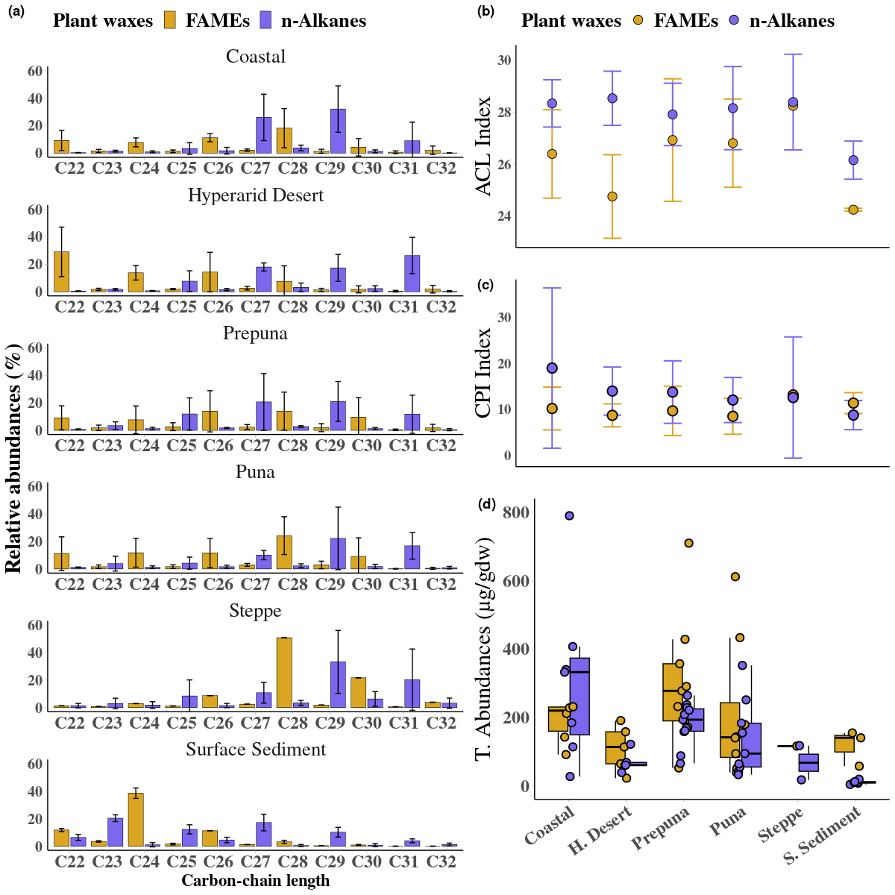

**2.2.3. Figure 3:**

**Importantly, you must define what the colored (purple) bands mean in this figure. Are these pluvial periods, for example? Don’t make the reader infer what these bands mean.**

**Aesthetics for this figure could be improved. E.g., consider making the lines thicker.**

**Make the scales consistent. As it stands now, this figure is somewhat misleading because the scales are different from panel to panel.**

**I would also recommend making the font size larger for the axes. Hard to read now.**

*Reply to comment on 2.2.3.* Figure 3*: the purple bands represent five pluviometric anomalies described in the literature. We have added a description in the legend and reduced the number of phases to the main four: CAPE I (ca. 18 to 14.8 ka cal BP), CAPE II (ca. 13.0 to 8.6 and 8.1 to 7.6 ka cal BP), ~2.5 and MCA (ca. 1.2 and 0.8 ka cal BP).*

*We have homogenised the scales and improved the aesthetics of the figure. In addition, we have also increased the size of the fonts. We have added the following sentence to the legend description: “The purple bands represent of the pluviometric anomalies CAPE I (ca. 18 to 14.8 ka cal BP), CAPE II (ca. 13.0 to 8.6 and 8.1 to 7.6 ka cal BP), ~2.5 and MCA (ca. 1.2 and 0.8 ka cal BP) described in the Atacama Desert. Note the different magnitudes of the abundances.”*

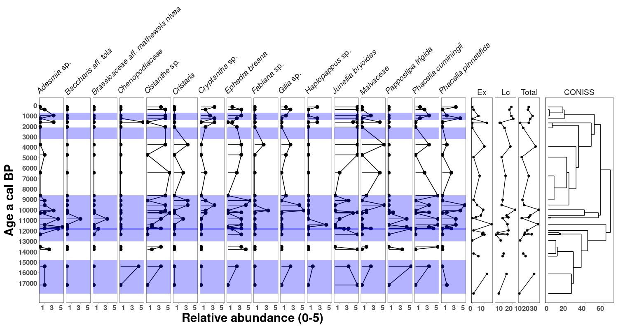

**2.2.4. Figure 4:**

**Same issue with the colored bands as mentioned above.**

**Same aesthetic issues as above.**

**Also, the scales are so different that you might have to log transform or somehow transform your data, so that they can be compared. If you do not want to transform the data, consider splitting into two different figures, or some alternative.**

*Reply to comment on 2.2.4.* Figure 4*: The scales are different because of the predominance of the C29 and C31 chain lengths, as explained in the text. We have clarified this in the legend by adding: Note the different scales of abundances. We have tried to improve the aesthetics of the figure following the reviewer's comments. Furthermore, we have increased the font size. In addition, we have also increased the size of the fonts. We applied a logarithmic transformation (scale_x_log10() in ggplot2) to make the data comparable, however, the low C21 values generate values that are difficult to plot, so we left the figure without any modification and added a note in the figure legend indicating the different abundances of the n-alkanes. We have added the following sentence to the legend description: “The purple bands represent of the pluviometric anomalies CAPE I (ca. 18 to 14.8 ka cal BP), CAPE II (ca. 13.0 to 8.6 and 8.1 to 7.6 ka cal BP), ~2.5 and MCA (ca. 1.2 and 0.8 ka cal BP) described in the Atacama Desert. Note the different magnitudes of the abundances.”*

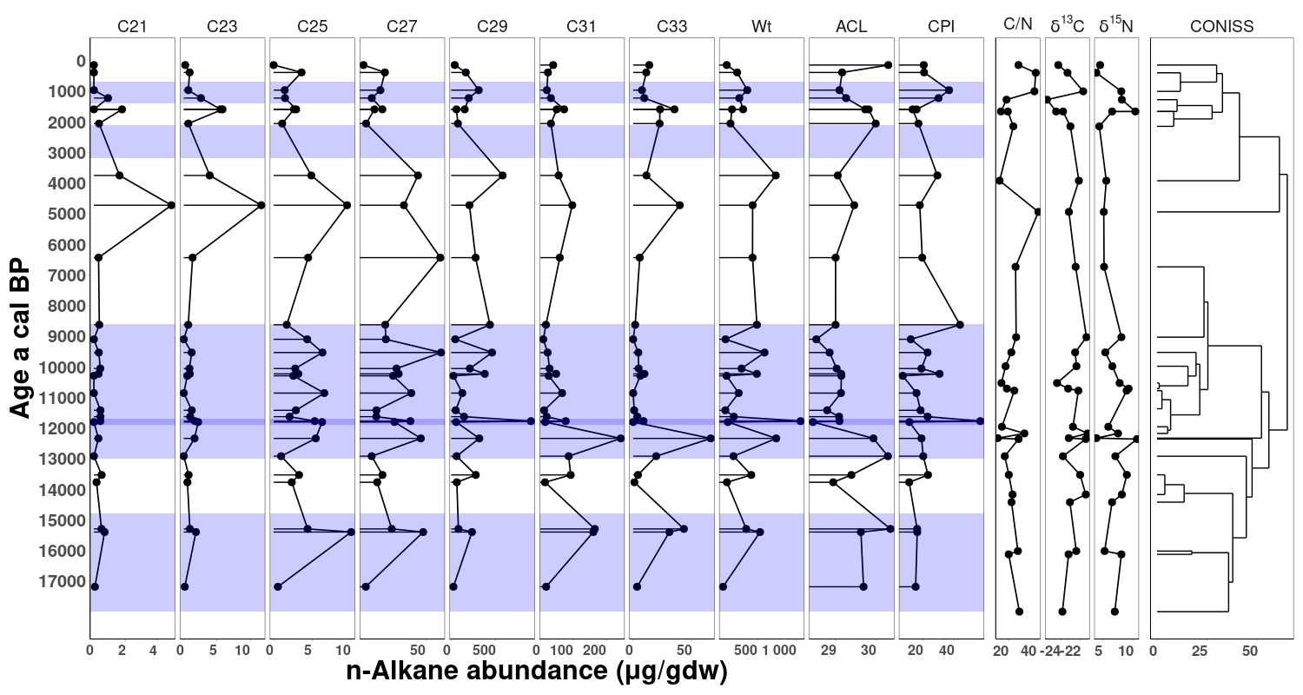

**2.2.5. Figure 5:**

**Panels (a)-(f) are difficult to read. Consider removing all the light colored gray lines and just using a shaded error bar for the confidence intervals. Alternatively, you could make the main black line much thicker to help draw the eye to that.**

**Please clearly define what the two thick vertical dashed black lines are. Are you marking the onset of the Holocene with one of those lines, for instance?**

**The axes titles for panels (c)-(e) should have 27, 29, and 31 as subscripts (i.e., C27)**

*Reply to comment on 2.2.5.* Figure 5*: We appreciate the reviewer's comment. We have made the suggested changes to Figure 5.*

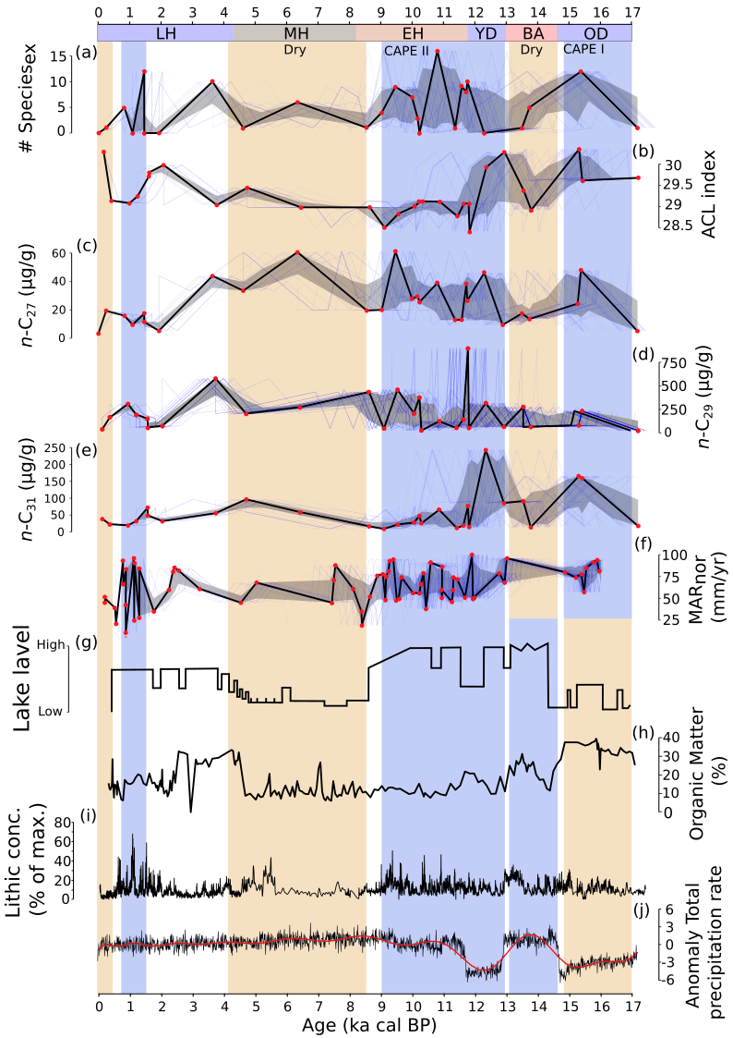

**2.2.6.**  **Table 1:**

**Consider adding a column that provides the common name for each species.**

**Also consider formatting the table to have alternating color bands for clarity/ease of readership**

*Response to comment on 2.2.6 Table 1: We appreciate the reviewer's comment. We have made the suggested changes to Table 1. We have created an editable latexfile with the changes.*

**2.2.7.** **Table 2:**

**Make sure to define all abbreviations used, e.g., ‘sd’ is standard deviation. You could define these in the captions.**

**Also be consistent with capitalization. All column categories should be capitalized, but right now some are and some are not.**

**I would also recommend adding a lower boundary line below the column categories, just to improve aesthetics. You could also align the category names in the center of each cell, and bold these.**

*Response to comment on 2.2.6 Table 2: we appreciate the reviewer's comment. We have made the suggested changes to Table 2. We have created an editable latexfile with the changes.*